**In class Exercise – 4/11/2019 – Due on or before Sunday 4/16 by midnight**

**Objective: All function types**

|  |
| --- |
| **Important instructions:**   * *All programs must include comments at the top of your program: your name,* the class name (CSIT 575)*, program name and* ***the program description (purpose of the program).*** * *Copy and paste your* ***program code*** *and* ***output*** *in Part B of each program. Note: Use snipping tool to snip the output.* * *Once it is done, save and submit this word file via Canvas.* |

**1. FavoriteCourse.cpp**

Write a program that asks the user to enter his/her name, favorite course, and the number of credit hours he/she is taking. The program will have the following function prototypes:

* void Header(); //writes header of the program (type 1)
* string AskName(); //asks and returns name of the user (type 3)
* string AskFavCourse(string name); // asks the user to enter his/her favorite course. The function is passed the user’s name and it returns a string. (type 4)
* int HowManyHours(string name, string course); // asks and returns the total number of credit hours he/she is taking this semester. To personalize the question, the user’s name and favorite course must pass to this function. (type 4)
* void Write(string name, string course, int hours);// Pass the name, favorite course and credit hours to the **Write** function, which writes these pieces of data to the screen. (type 2)

All functions are called from **main(). The main function includes a “do again” loop**

**Sample run:**

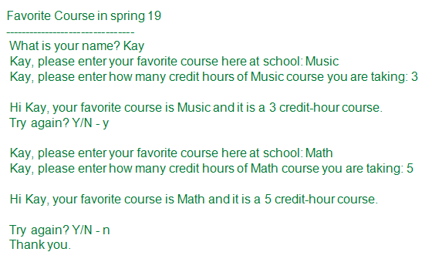

**Part B: Copy and paste your program (source) code and the outputs after this line**

**+++++++++++++++++++++++++++++++++++++++++++++++++**

/* Erik Gonzalez

CO SCI 575

FavoriteCourse.cpp

asks the user to enter his/her name, favorite course, and the number of credit hours he/she is taking.

*/

#include <iostream>

#include <string>

using namespace std;

void Header();

string AskName();

int HowManyHours(string name, string course);

void Write(string name, string course, int hours);

string AskFavCourse(string);

int main()

{

string name;

string inputCourse;

string again;

int inputHours;

Header();

name = AskName();

inputCourse = AskFavCourse(name);

inputHours = HowManyHours(name, inputCourse);

Write(name, inputCourse, inputHours);

cout << "\nTry again? Y/N - ";

cin >> again;

//Proccessing

while (again == "Y" || again == "y")

{

cout << "\n";

inputCourse = AskFavCourse(name);

inputHours = HowManyHours(name, inputCourse);

Write(name, inputCourse, inputHours);

cout << "\nTry again? Y/N - ";

cin >> again;

}

if (again == "N" || again == "n")

{

cout << "Thank you.\n";

system("pause");

return 0;

}

}

//Ouput

void Header()

{

cout << "Favorite Course in Spring 19" << endl;

cout << "-------------------------------------" << endl;

}

//input

string AskName()

{

string name;

cout << "What is your name? ";

cin >> name;

return name;

}

//output and input

string AskFavCourse(string name)

{

string course;

cout << name << ", pleaser enter your favorite course here at school: ";

cin >> course;

return course;

}

//input and output

int HowManyHours(string name, string course)

{

int hours;

cout << name << ", please enter how many credits hours of " << course << " you are taking: ";

cin >> hours;

return hours;

}

//output

void Write(string name, string course, int hours)

{

if (hours == 3)

cout << "\nHi " << name << ", your gavorite course is " << course << " and it is a 3 hour course.";

if (hours == 5)

cout << "\nHi " << name << ", your gavorite course is " << course << " and it is a 5 hour course.";

}

OUTPUTS:

Favorite Course in Spring 19

-------------------------------------

What is your name? Erik

Erik, pleaser enter your favorite course here at school: Music

Erik, please enter how many credits hours of Music you are taking: 5

Hi Erik, your gavorite course is Music and it is a 5 hour course.

Try again? Y/N - Y

Erik, pleaser enter your favorite course here at school: C++

Erik, please enter how many credits hours of C++ you are taking: 3

Hi Erik, your gavorite course is C++ and it is a 3 hour course.

Try again? Y/N - y

Erik, pleaser enter your favorite course here at school: band

Erik, please enter how many credits hours of band you are taking: 5

Hi Erik, your gavorite course is band and it is a 5 hour course.

Try again? Y/N - n

Thank you.

OUTPUT 2:

Favorite Course in Spring 19

-------------------------------------

What is your name? Erik

Erik, pleaser enter your favorite course here at school: C++

Erik, please enter how many credits hours of C++ you are taking: 5

Hi Erik, your gavorite course is C++ and it is a 5 hour course.

Try again? Y/N - N

Thank you.